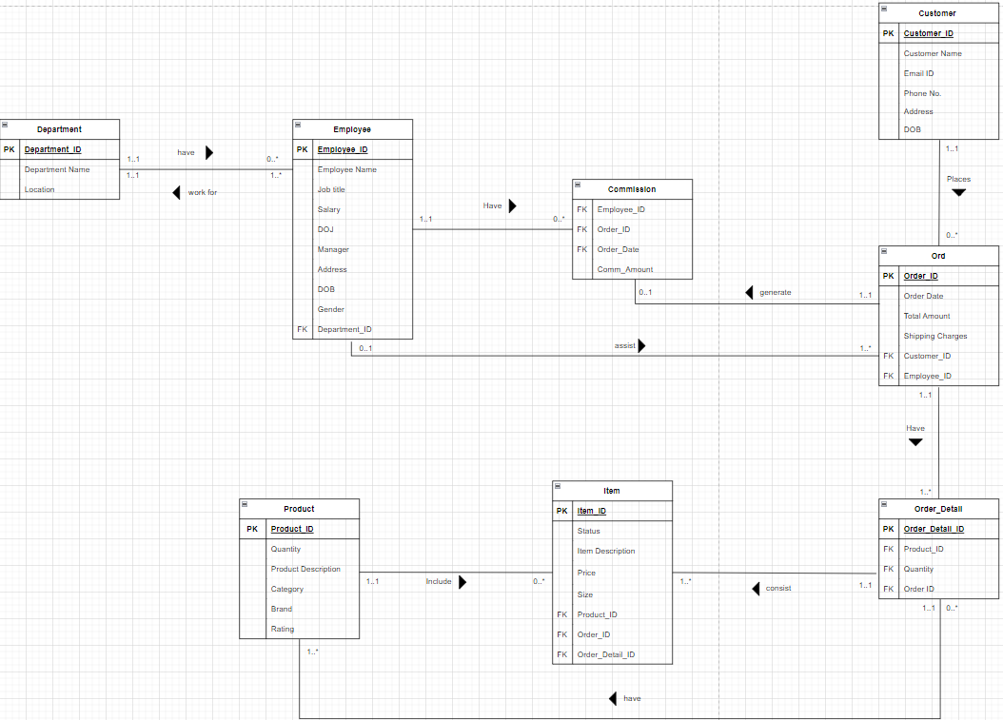

|  |  |  |  |
| --- | --- | --- | --- |
| **Entity** | **Primary Key (PK)** | **Foreign Key (FK)** | **Rationale for PK** |
| Department | Department_ID | N/A | A unique ID for each Department |
| Employee | Employee_ID | Department_ID | A unique ID for Each employee. |
| Customer | Customer_ID | N/A | A unique ID for each Customer |
| Ord | Order_ID | Customer_ID, Employee_ID | A unique ID for each Order |
| Order_Detail | Order_Detail_ID | Product_ID, Quantity, Order ID | A unique ID for each Order’s individual Item |
| Item | Item _ID | Product_ID, Order_ID, Order_Detail_ID | A unique ID for each Item |
| Product | Product_ID | N/A | A unique ID for each Product |
| Commission | N/A | Employee_ID, Order_ID, Order_Date | Commission ID is not used in any table as an FK. |

|  |  |  |
| --- | --- | --- |
| Entity | Attributes | Rationale for attribute |
| Department | Department_Name  Location | -To specify where each employee will be assigned to  -To know the location of each department |
| Employee | Employee_Name  Job_title  Salary  DOJ  Manager  Address  DOB  Gender | - To know the individual employ’s information  - To know the individual employ’s information  - To know the individual employ’s information  - TO know when the corresponding employee joined  - To know who the employee reports to  - To know the individual employ’s information  - To know the individual employ’s information  - To know the individual employ’s information |
| Customer | Customer Name  Email ID  Phone No.  Address  DOB | - To know the individual customer’s information  - To know the individual customer’s information  - To know the individual customer’s information  - To know the individual customer’s information  - To know the individual customer’s information |
| Order | Order Date  Total Amount  Shipping Charges | -To know when the order placed  -To display the total amount for the order  -To display the shipping charges according to the order |
| Product | Quantity  Product Description  Category  Brand  Rating | -To check of the product’s stock  - To show more information of the product to the customers  -To know the product falls under which category  - To know the product falls under which Brand.  - To show the customers the rating according to the product which helps them decide. |
| Item | Status  Item Description  Price  Size | -To the know the quality of the product  -To inform the customers more about what they are purchasing  -To the price of an item  - To the size of the item |
| Order_Detail | Product_ID  Quantity  Order ID | -To show the customer which product they have purchased  - To show what is the quantity of the item they have bought  - To inform the customer about the Order_ID which will help them identify the order. |

Relationships between entities:

|  |  |  |
| --- | --- | --- |
| Department to Employee | | |
| Cardinality | Participation | Reasons |
| 1...0  1...* | - A Department may not have employees  - A Department may have many employees | - Not employed for the Newly formed departments  - Department may working on a project |
| Employee to Department | | |
| Cardinality | Participation | Reason |
| 1…1  *…1 | * One employee may work for only one Department * Many employees may work for only one Department | * Decided according to the Job title. * Within the department the tasks will be shared among the employees |

|  |  |  |
| --- | --- | --- |
| Employee to Commission | | |
| Cardinality | Participation | Reason |
| 1…0  1…* | -Each employee may not have any commission  -Each employee may have more than one commission. | - The commission are only given to salesman  - Salesman who assisted with more orders get more commission. |

|  |  |  |
| --- | --- | --- |
| Employee to Ord | | |
| Cardinality | Participation | Reasons |
| 0…1  1...* | - No employees assist with an order  - One employee assist with many order | - The customer didn’t take help from the employee  - One employee helped many customers with their |

|  |  |  |
| --- | --- | --- |
| Ord to Commission | | |
| Cardinality | Participation | Reasons |
| 1…0  1…1 | * One order may generate no commission * One order may generate only one commission | * The employee who helped wasn’t a salesman * The salesman helped with more than one order |

|  |  |  |
| --- | --- | --- |
| Customer to Ord | | |
| Cardinality | Participation | Reasons |
| 1…0  1…* | - One Customer may not place any order  - One Customer may place more than one order | - Customer was window shopping  - Customer may order many times in the past few days |

|  |  |  |
| --- | --- | --- |
| Ord to Order_Detail | | |
| Cardinality | Participation | Reasons |
| 1…1  1...* | - One Order may have only one order details  - One Order many have many order details | - The customer only purchased one item  - The customer purchased more than one item |

|  |  |  |
| --- | --- | --- |
| Order_Detail to Item | | |
| Cardinality | Participation | Reasons |
| 1…1  1…* | - One order detail may consist of only one item  - One order detail may consist of many items | * The customer only ordered one item * The customer ordered many items |

|  |  |  |
| --- | --- | --- |
| Order_Detail to Product | | |
| Cardinality | Participation | Reasons |
| 1…1  1...* | - One order detail may have only one product  - One order detail may have more than one product. | * The customer only purchased one product * - The customer purchased more than one product |

|  |  |  |
| --- | --- | --- |
| Product to Item | | |
| Cardinality | Participation | Reasons |
| 1…0  1…* | - One product may include no item  - One product may include more than one item. | * The product may be out of stock * There is more than one individual item of that product |

SQL:

DROP TABLE IF EXISTS Department;

CREATE TABLE Department

(Department_ID INT ,

Department_Name VARCHAR(225),

Location VARCHAR(225),

CONSTRAINT pk_Department_DepartmentID PRIMARY KEY (Department_ID));

insert into Department (Department_ID,Department_Name,Location) values (1001,'Research','Hammersmith');

insert into Department (Department_ID,Department_Name,Location) values (1002,'Sales','Fulham');

insert into Department (Department_ID,Department_Name,Location) values (1003,'Accounts','Tottenham Court Road');

insert into Department (Department_ID,Department_Name,Location) values (1004,'Shipment','Tottenham Court Road');

-----------

DROP TABLE IF EXISTS Employee;

CREATE TABLE Employee

(Employee_ID INT,

Employee_Name VARCHAR(225),

Job_title VARCHAR(225),

Salary FLOAT,

DOJ DATE,

Manager INT,

Address VARCHAR(225),

DOB DATE,

Gender VARCHAR(25),

Department_ID INT,

CONSTRAINT pk_Employee_EmployeeID PRIMARY KEY (Employee_ID),

CONSTRAINT fk_Employee_DepartmentID FOREIGN KEY (Department_ID) REFERENCES Department (Department_ID));

Insert into Employee (Employee_ID,Employee_Name, Job_tItle, Salary, DOJ, Manager, Address, DOB, Gender, Department_ID ) values(10001,'James','Salesman',3500,'2021-05-12',10004,' 99 Main Road,Auchleven,AB52 5QE,United Kingdom','1989-04-03','Male',1002);

Insert into Employee (Employee_ID,Employee_Name, Job_tItle, Salary, DOJ, Manager, Address, DOB, Gender, Department_ID ) values(10002,'Charles','Accountant',5000,'2021-03-15',10010,'15 Sandyhill Rd,Froxfield Green,GU32 4HA,United Kingdom','1980-03-08','Male',1003);

Insert into Employee (Employee_ID,Employee_Name, Job_tItle, Salary, DOJ, Manager, Address, DOB, Gender, Department_ID ) values(10003,'Jeff','Analyst',6000,'2021-04-16',10004,'68 Monks Way, Toppings, BL7 8BF, United Kingdom','1984-11-14','Male',1001);

Insert into Employee (Employee_ID,Employee_Name, Job_tItle, Salary, DOJ, Manager, Address, DOB, Gender, Department_ID ) values(10004,'Karl','Manager',8000,'2021-06-21',10005,'54 Middlewich Road, Fiunary, PA34 1TR, United Kingdom','1973-12-16','Male',1001);

Insert into Employee (Employee_ID,Employee_Name, Job_tItle, Salary, DOJ, Manager, Address, DOB, Gender, Department_ID ) values(10005,'Tommy','President',10000,'2021-11-30',NULL,'37 Stone St, Craigmyle Ho., AB31 3AX, United Kingdom','1999-05-03','Male',NULL);

Insert into Employee (Employee_ID,Employee_Name, Job_tItle, Salary, DOJ, Manager, Address, DOB, Gender, Department_ID ) values(10006,'Katie','Analyst',6000,'2021-07-14',10004,'75 Broomfield Place, Stonebridge, CV7 5JH, United Kingdom','1974-02-26','Female',1001);

Insert into Employee (Employee_ID,Employee_Name, Job_tItle, Salary, DOJ, Manager, Address, DOB, Gender, Department_ID ) values(10007,'Stacy','Accountant',5000,'2021-08-02',10010,'92 Southend Avenue, Blackborough End, PE32 6RU, United Kingdom','1978-08-03','Female',1003);

Insert into Employee (Employee_ID,Employee_Name, Job_tItle, Salary, DOJ, Manager, Address, DOB, Gender, Department_ID ) values(10008,'Nency','Salesman',3500,'2021-09-28',10004,'81 Marlborough Crescent, South Muskham, NG23 9ZL, United Kingdom','1980-03-03','Female',1002);

Insert into Employee (Employee_ID,Employee_Name, Job_tItle, Salary, DOJ, Manager, Address, DOB, Gender, Department_ID ) values(10009,'Sung Jin Woo','Shipper',2000,'2021-08-17',10010,'30 Temple Way, Wivenhoe, CO7 8NX, United Kingdom','1999-09-03','Male',1004);

Insert into Employee (Employee_ID,Employee_Name, Job_tItle, Salary, DOJ, Manager, Address, DOB, Gender, Department_ID ) values(10010,'Maria','Manager',8000,'2021-02-25',10005,'32 Wartnaby Road, Aigburth, L17 8RY, United Kingdom','1980-05-03','Female',1004);

------------

DROP TABLE IF EXISTS Customer;

CREATE TABLE Customer

(Customer_ID INT,

Customer_Name VARCHAR(225),

Email_ID VARCHAR(225),

Phone_No VARCHAR(25),

Address VARCHAR(225),

DOB DATE,

CONSTRAINT pk_Customer_CustomerID PRIMARY KEY (Customer_ID));

Insert into Customer (Customer_ID,Customer_Name,Email_ID, Phone_No,Address, DOB ) values(12344,'Talia','Tailia@tailia.com','xx6-xxx-x',' 56 Main Road,Auchleven,AB42 5QE,United Kingdom','2010-08-09');

Insert into Customer (Customer_ID,Customer_Name,Email_ID, Phone_No,Address, DOB ) values(12345,'Simon','Simon@simon.com','xx7-xxx-x','37 Stone St, Craigmyle Ho., AC31 3AX, United Kingdom','2013-09-07');

Insert into Customer (Customer_ID,Customer_Name,Email_ID, Phone_No,Address, DOB ) values(12346,'Ethan','ethan@ethan.com','xx8-xxx-x','02 Temple Way, Wivenhoe, CO5 3NX, United Kingdom','1984-12-05');

Insert into Customer (Customer_ID,Customer_Name,Email_ID, Phone_No,Address, DOB ) values(12347,'Josh','josh@josh.com','xx9-xxx-x','74 Broomfield Place, Stonebridge, CV7 5JH, United Kingdom','1956-11-06');

Insert into Customer (Customer_ID,Customer_Name,Email_ID, Phone_No,Address, DOB ) values(12348,'Vikram','Vikram@Vikram.com','x10-xxx-x','60 Monks Way, Toppings, BL7 8BF, United Kingdom','2001-05-03');

Insert into Customer (Customer_ID,Customer_Name,Email_ID, Phone_No,Address, DOB ) values(12349,'Randolph','Randolph@randolph.com','x11-xxx-x','52 Wartnaby Road, Aigburth, L17 8RY, United Kingdom','1974-02-04');

-------

DROP TABLE IF EXISTS Product ;

CREATE TABLE Product

(Product_ID VARCHAR(225),

Quantity INT,

Product_Description VARCHAR(360),

Category VARCHAR(225),

Brand VARCHAR(225),

Rating Float,

CONSTRAINT pk_Product_ProductID PRIMARY KEY (Product_ID));

insert into Product (Product_ID, Quantity, Product_Description, Category, Brand, Rating) values('P1001',5,'Trackpants for Men','Clothes','Adidas',4.3);

insert into Product (Product_ID, Quantity, Product_Description, Category, Brand, Rating) values('P1002',6,'Light Shoes for Women','Shoes','Puma',4.4);

insert into Product (Product_ID, Quantity, Product_Description, Category, Brand, Rating) values('P1003',3,'Lucky Watch','Accessories','Kaybu',0);

insert into Product (Product_ID, Quantity, Product_Description, Category, Brand, Rating) values('P1004',0,'slim performance Grand','Laptop','Apple',4.8);

insert into Product (Product_ID, Quantity, Product_Description, Category, Brand, Rating) values('P1005',2,'Dry try fry','Laptop','Google',4.8);

--------

DROP TABLE IF EXISTS Ord;

CREATE TABLE Ord

(Order_ID VARCHAR(225),

Order_Date DATE,

Total_Amount Float,

Currency_Code VARCHAR(25),

Shipping_Charges Float,

Customer_ID INT,

Employee_ID INT,

CONSTRAINT pk_Ord_OrderID PRIMARY KEY (Order_ID),

CONSTRAINT fk_Ord_CustomerID FOREIGN KEY (Customer_ID) REFERENCES Customer (Customer_ID),

CONSTRAINT fk_Ord_EmployeeID FOREIGN KEY (Employee_ID) REFERENCES Employee (Employee_ID));

insert into Ord (Order_ID,Order_Date,Total_Amount,Currency_Code,Shipping_Charges,Customer_ID,Employee_ID) values('O1001','2022-12-06',45.00,'GBP',2.00,12344,10001);

insert into Ord (Order_ID,Order_Date,Total_Amount,Currency_Code,Shipping_Charges,Customer_ID,Employee_ID) values('O1002','2022-12-09',29.00,'GBP',0.00,12346,10001);

insert into Ord (Order_ID,Order_Date,Total_Amount,Currency_Code,Shipping_Charges,Customer_ID,Employee_ID) values('O1003','2022-12-16',157.00,'GBP',2.00,12346,10010);

insert into Ord (Order_ID,Order_Date,Total_Amount,Currency_Code,Shipping_Charges,Customer_ID,Employee_ID) values('O1004','2022-12-11',29.00,'GBP',2.00,12349,10003);

insert into Ord (Order_ID,Order_Date,Total_Amount,Currency_Code,Shipping_Charges,Customer_ID,Employee_ID) values('O1005','2022-09-13',45.00,'GBP',0.00,12348,10008);

-----

DROP TABLE IF EXISTS Order_Detail ;

CREATE TABLE Order_Detail

(Order_Detail_ID VARCHAR(225),

Quantity INT,

Product_ID VARCHAR(225),

Order_ID VARCHAR(225),

CONSTRAINT pk_OrderDetail_OrderDetailID PRIMARY KEY (Order_Detail_ID),

CONSTRAINT fk_OrderDetail_ProductID FOREIGN KEY (Product_ID) REFERENCES Product (Product_ID),

CONSTRAINT fk_OrderDetail_OrderID FOREIGN KEY (Order_ID) REFERENCES Ord (Order_ID));

insert into Order_Detail (Order_Detail_ID, Product_ID, Quantity, Order_ID) values('ODI1001','P1003',1,'O1001');

insert into Order_Detail (Order_Detail_ID, Product_ID, Quantity, Order_ID) values('ODI1002','P1001',1,'O1002');

insert into Order_Detail (Order_Detail_ID, Product_ID, Quantity, Order_ID) values('ODI1003','P1005',1,'O1003');

insert into Order_Detail (Order_Detail_ID, Product_ID, Quantity, Order_ID) values('ODI1004','P1001',1,'O1004');

insert into Order_Detail (Order_Detail_ID, Product_ID, Quantity, Order_ID) values('ODI1005','P1003',1,'O1005');

--------------

DROP TABLE IF EXISTS Item ;

CREATE TABLE Item

(Item_ID VARCHAR(225),

Status VARCHAR(225),

Item_Description VARCHAR(360),

Price Float,

Currency_Code VARCHAR(25),

Shipping_Charges Float,

Size Float,

Product_ID VARCHAR(225),

Order_ID VARCHAR(225),

Order_Detail_ID VARCHAR(225),

CONSTRAINT pk_Item_ItemID PRIMARY KEY (Item_ID),

CONSTRAINT fk_item_ProductID FOREIGN KEY (Product_ID) REFERENCES Product (Product_ID),

CONSTRAINT fk_Item_OrderID FOREIGN KEY (Order_ID) REFERENCES Ord (Order_ID),

CONSTRAINT fk_item_OrderDetailID FOREIGN KEY (Order_Detail_ID) REFERENCES Order_Detail (Order_Detail_ID));

insert into Item (Item_ID, Status, Item_Description, Price, Currency_Code, Size, Product_ID, Order_ID, Order_Detail_ID) values('I1001','Defective','Watch Made of Leather and precise time',45.00,'GBP',10,'P1003','O1001','ODI1001');

insert into Item (Item_ID, Status, Item_Description, Price, Currency_Code, Size, Product_ID, Order_ID, Order_Detail_ID) values('I1002','Refurbished','Made of Silk',29.00,'GBP',9.5,'P1001','O1002','ODI1002');

insert into Item (Item_ID, Status, Item_Description, Price, Currency_Code, Size, Product_ID, Order_ID, Order_Detail_ID) values('I1003','Refurbished','12 RAM and 8 ROM',157.00,'GBP',9,'P1005','O1003','ODI1003');

insert into Item (Item_ID, Status, Item_Description, Price, Currency_Code, Size, Product_ID, Order_ID, Order_Detail_ID) values('I1004','New','Made of Silk',29.00,'GBP',7,'P1001','O1004','ODI1004');

insert into Item (Item_ID, Status, Item_Description, Price, Currency_Code, Size, Product_ID, Order_ID, Order_Detail_ID) values('I1005','New','Watch Made of Leather and precise time',45.00,'GBP',10.5,'P1003','O1005','ODI1005');

---------------------

DROP TABLE IF EXISTS Commission ;

CREATE TABLE Commission

(Order_ID VARCHAR(225),

Employee_ID INT,

Order_Date DATE,

Comm_Amount Float,

CONSTRAINT fk_Commission_EmployeeID FOREIGN KEY (Employee_ID) REFERENCES Employee (Employee_ID),

CONSTRAINT fk_Commission_OrderID FOREIGN KEY (Order_ID) REFERENCES Ord (Order_ID));

insert into Commission

SELECT a.Order_ID,b.Employee_ID,a.Order_Date, a.Total_Amount * 10/100 FROM Ord a, Employee b

where a.Employee_ID = b.Employee_ID

and b.Job_title = 'Salesman';

*Query:*

-- List of employees based on the Department - 1

SQL:

Select b.Department_Name,b.Location,a.Employee_ID, a.Employee_Name,a.Job_title

from Employee a, Department b

where a.Department_id = b.Department_ID

order by b.Department_Name,b.Location

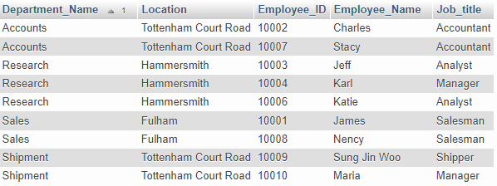

-- List of Employees who helped Customer with order. - 2

SQL:

SELECT b.Employee_Name, b.Job_title,c.Customer_Name, a.Order_ID, a.Order_Date

FROM Ord a, Employee b, Customer c

where a.Employee_ID = b.Employee_ID

and a.Customer_ID = c.Customer_ID

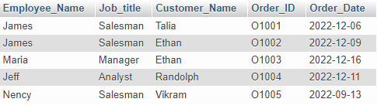

--List number of customers helped by the employees – 3

SQL:

SELECT b.Employee_Name, b.Job_title,count(a.Customer_Id) Number_of_Customers_helped

FROM Ord a, Employee b

where a.Employee_ID = b.Employee_ID

group by b.Employee_Name, b.Job_title

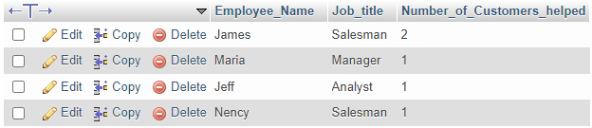

---Find the Senior citizen customers to send the promotion email for additional 10% discount. – 4

SQL:

select Customer_Name,Email_ID, DOB

from Customer

where (DATEDIFF(CURDATE(),DOB))/365 >= 65;



---List of Products and it’s status - 5

select a.Product_ID, a.Product_Description,a.Category, a.Brand,b.Item_id, b.Item_description, b.Status,b.Price,b.Currency_Code

from

Product a, Item b

where a.Product_ID = b.Product_ID

order by a.Product_ID, b.Item_ID

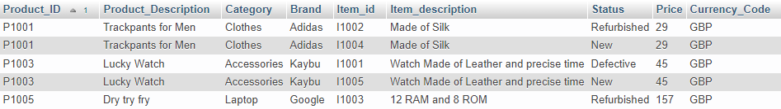

--Number of Orders placed with total amount spent by each Customers in last 1 month - 6

SQL:

select b.Customer_Name, count(a.order_id) No_Orders ,sum(a.Total_Amount) Total_Expenditure_in_last_1_Month

from Ord a, Customer b

where a.Customer_ID = b.Customer_ID

and a.Order_Date >= Date_Sub(CURDATE(), INTERVAL 1 Month)

group by b.Customer_Name;

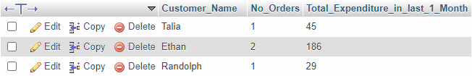

* Complete information of the order placed in last 6 months - 8

SQL:

select a.Order_id,f.Customer_Name, c.Product_description, c.Brand,c.Category,d.Item_Description, d.Status,d.Price,a.shipping_charges, d.Currency_Code, f.Address, e.Employee_Name

from Ord a, Order_Detail b, Product c, Item d, Employee e, Customer f

where a.order_id= b.order_id

and b.product_id = c.product_id

and c.product_id = d.product_id

and a.employee_id = e.Employee_ID

and a.Customer_ID = f.Customer_ID

and d.order_detail_id = b.Order_Detail_ID

and a.Order_Date >= Date_Sub(CURDATE(), INTERVAL 6 Month)



* Commission earned by employees in last one year - 9

SQL:

select Employee_Name,sum(c.total_amount) Order_Total_Amount, sum(Comm_Amount) Total_Commission_Earned

from Commission a, Employee b, Ord c

where a.Employee_ID = b.Employee_ID

and c.Order_Id = a.Order_ID

and a.Order_Date >= Date_Sub(CURDATE(), INTERVAL 1 Month)

group by Employee_Name



--- Products purchased by customers in last 1 months – 10

SQL:

select b.Product_description,b.Brand,c.Item_description, count(Item_description) No_Items_Sold

from Product b, Item c, Order_Detail d, Ord a

where a.Order_id = d.Order_ID

and b.Product_id = d.Product_ID

and c.Order_detail_Id = c.Order_Detail_ID

and b.Product_ID = c.Product_ID

and a.Order_Date >= Date_Sub(CURDATE(), INTERVAL 1 Month)

group by b.Product_description,b.Brand,c.Item_description

order by b.Product_description,b.Brand,c.Item_description

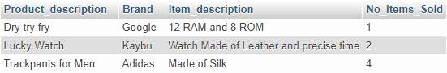

References:

Values of Address for entities: Employee and Customer:

[Random Address In United Kingdom | Best Random Tools (bestrandoms.com)](https://www.bestrandoms.com/random-address-in-uk)

SQL Data Types For Entitles:

[SQL Data Types for MySQL, SQL Server, and MS Access (w3schools.com)](https://www.w3schools.com/sql/sql_datatypes.asp#:~:text=The%20data%20type%20of%20a%20column%20defines%20what,stored%20inside%20each%20column%20when%20creating%20a%20table.)

Date and time functions:

[MySQL :: MySQL 5.7 Reference Manual :: 12.7 Date and Time Functions](https://dev.mysql.com/doc/refman/5.7/en/date-and-time-functions.html#function_datediff)